**ARTS MAG INTERVIEW – SAMIR DAMJI:**

• Interesting fact about yourself:

Call me Chef Damji! In my spare time, I love cooking! I frequently cook at family gatherings where I love to mix together different herbs and spices and create a different concoction each time. When I cook, it serves as an outlet for me to get creative – my dishes are different every time! The most rewarding feeling is when I’m at the dinner table and everyone’s plates are clean – that’s when I know I have succeeded. Don’t get me wrong; I have had plenty of mess-ups! It’s all part of the process, however, in order to master this culinary art form. My favorite dish to make is “Boeuf Bourguignon” – Julia Childe style of course!

• Your background (anything that you would like to share, does your family have a history of public speaking)

Growing up, I always observed my father delivering speeches at my local mosque. His confidence, professional poise, and masterful pauses all captivated the audience. You can just tell when an audience is captivated; everyone’s slightly leaning forward and on the edge of their seat. Being a part of the audience and watching my father for several years, I picked up on his natural nuances and also observed how an effective delivery of a speech can really grab the audience’s attention.

• Your interests and hobbies (other than public speaking):

Basketball is my passion! I live, breathe, eat, and sleep basketball. It is such a great sport - it is fast paced and being part of a team has allowed me to make life-long friendships. This year, I am a member of the senior basketball team, and our team has a shot at winning a provincial title this year! Outside of basketball, I hold positions with a variety of clubs: Chair of the West Vancouver Youth Advisory Council, President of CCMP, Vice President of Target Alpha (inter –school stock trading competition), staff writer for the Ad Verum, etc.

• Your philosophy (views) on public speaking (what does « public speaking as a means of expression» mean to you):

Statistics show that public speaking is more feared than death! Personally, I look at public speaking as an opportunity – an opportunity to express my opinions and ideas in front of a large audience. How often do you get that chance? All eyes and ears on you, giving only ***you*** their full attention.

Public speaking is a wonderful art form. It is an opportunity to persuade an audience, and opportunity to humor an audience, an opportunity to bring an audience to tears – but most of all, it’s an opportunity to express oneself! It’s not just verbal; it’s the facial expressions, it’s the hand actions – it is such a nuanced art form! Everyone applies their own brush strokes and techniques, and this space for creativity and uniqueness is what defines public speaking.

Since I am the lead in many of these initiatives, public speaking is important in all of these things. That’s the thing about public speaking – it applies to every facet of life! Whether it’s a team huddle in basketball or hosting an event, confidence to speak in front of a group of people is an important skill!

• At what age did you start public speaking?

The first time I did public speaking was at the school’s annual public speaking competition in grade 1. After grade 1, when I discovered my passion for public speaking, I started winning gold year after year. I am the current gold medal record holder at the school with 9 consecutive gold medals at the annual competition.

• Do you do public speaking outside of Collingwood?

While I do not compete in formal public speaking competitions outside of school, I public speak on a daily basis. I am fortunate to be in a leadership position in several initiatives, and frequently speak at conferences, meetings, and events. For instance, I am the CEO of my SHAD team and was given the opportunity to speak in front of entrepreneurs and leaders from all across Canada a couple of weeks ago.

• Which speeches are you most proud of?

The speech I am most proud of would be my grade six speech, where I took on the persona of Dr. Seuss. When I delivered that speech, it was the first time I knew that I had the audience captivated: its the feeling I described above when my dad spoke in my mosque, everyone leaning forward at the edge of their seats. I worked extremely hard in writing the speech, cleverly placing quotes at different parts in the speech and making certain lines rhyme!

• Are there different styles/genres of public speaking you prefer?

Traditionally, I have excelled with the Persuasive speech category, as I am passionate in expressing my opinion on certain issues. Recently, however, with the change in the format of the public speaking competition at Collingwood, I have been exposed to genres such as Interpretative read, After Dinner speaking, and Radio Newscast. These have all pushed my boundaries, but diversified me and ameliorated my public speaking ability. Radio Newscast, an impromptu category, was a category in which I placed 2nd place at the International Public Speaking competition in Toronto last month!

• Who or what has influenced your public speaking?

My father is extremely articulate and eloquent whenever he speaks…he has probably had the most influence on me.

• Your future aspirations (do you plan to pursue public speaking after high school?):

Public speaking is a part of my life! I can’t avoid it. It will play an important role in whatever I choose to pursue.

After high school, while in university, I plan to pursue public speaking further. I plan on joining toastmasters international, the largest adult public speaking organization in the world. I aspire to compete in the world championships one day!

In addition, I will pursue any public speaking opportunities offered at the university I attend. I may join a team, etc.

• Awards/Accomplishments:

9 Consecutive gold medals at Collingwood annual public speaking competition– school record holder

International Public speaking competition – 2nd place in Radio Newscast

First place after dinner category last year

• Final/Extra Comments (and/or a quote you would like included):

*“There are three types of speeches. The one you practiced, the one you gave, and the one you wish you gave.”* – Dale Carneghie

**• Please send some pictures of you speaking, a profile picture for your page on Arts Mag, as well as footage of you speaking to be featured!**

Prof Pic

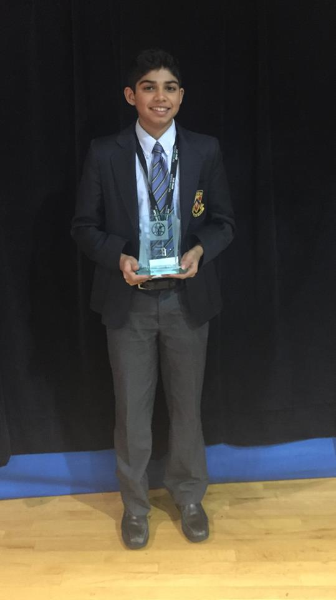

Other pics

*Winning first place in grade four at the annual public speaking competition*

